How to Connect to the Filemaker Server Using Filemaker Pro 19 or 20 Windows
(8/24/2023)
Here are some instructions for connecting to the Filemaker server in College of Ag Sciences using Filemaker Pro 19 or 20 on a Windows computer. These instructions assume that:
- You have the Filemaker Pro application installed on your local computer.
- You have permission to access one or more databases on our Filemaker server.
Finance & Business Operations maintains a Filemaker server with the host internet address:
a8-as-fm-1.ad.psu.edu
1. Start Filemaker Pro from your desktop or Start menu.
- The Filemaker Pro application icon looks like a black circle or a stylized “F”
(Filemaker 19) (Filemaker 20)
- If Filemaker Pro does not appear in your applications list, please contact Ag IT or us (Albert Nakpil or Craig Story).
2. Click "Edit" in the menu bar then select "Preferences...". In the Preferences window, enter your PSU UserID (such as xyz1234) then click OK.
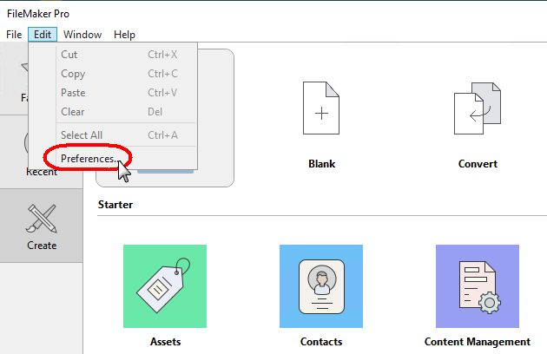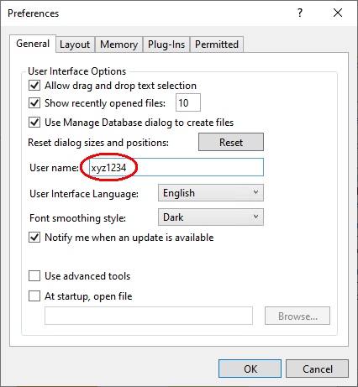

3. In the Filemaker Pro window, click "Favorites" then "Add App" and select "From Hosts...".
The "Favorites" tile is designed to contain your list of favorite or frequently-used databases.
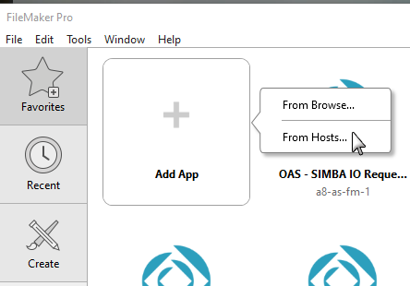
4. In the Hosts window, click on the "+" symbol to add a favorite host.
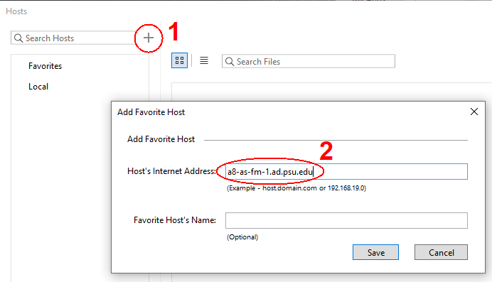
5. In the Host’s Internet Address of the Add Favorite Host window, type:
a8-as-fm-1.ad.psu.edu then click the Save button.

6. If a Windows Security Alert dialog box appears, click Cancel.
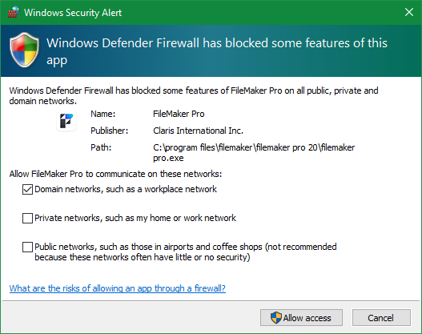
7. You may need to enter your password to view the databases on the server.
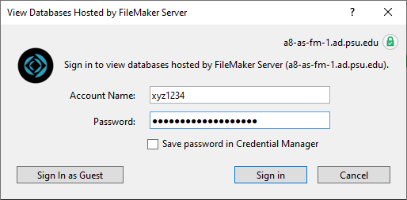

8. Once the list of databases is displayed, select a database to add to your "Favorites" list. To select multiple databases, hold down the Shift key and click on the database.
9. The database or databases that you selected should now appear in your "Favorites" list.
10. To open a database, click on "Favorites" and then double-click on a database. You may be asked to enter your password.
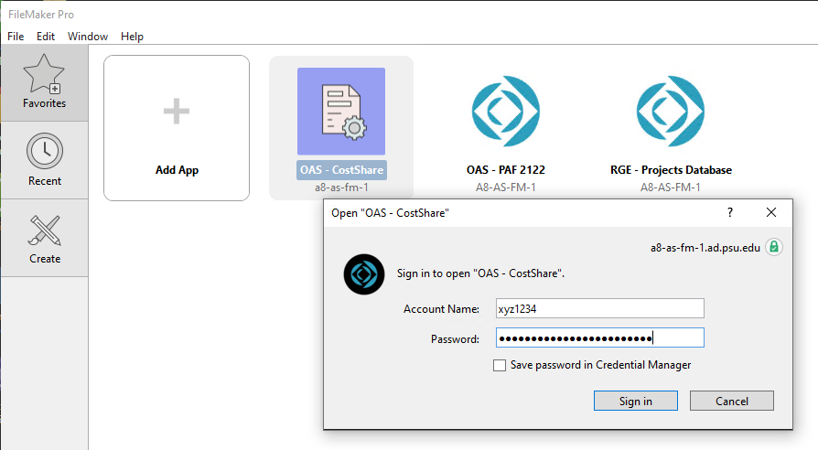

You can also open databases by clicking on "Recent" or by going to File on the menu bar then selecting Favorites, Hosts or Open...
Tips: You can move database tiles around in Favorites to help you organize them. To remove a database in Favorites, just right-click and select Remove.
The Filemaker server is on the EAD (Penn State Active Directory) domain which means users will login with their Penn State username and password.
Please contact Albert Nakpil (aln@psu.edu) or Craig Story (crs3@psu.edu) if you need additional help connecting to the Filemaker Servers using Filemaker Pro 19 or 20.
6/2/2023 aln – updated screenshot for Windows Security Alert

